create a new user with the privilege of sudo

# Check current users

# Create a new user named username

add a user named username

useradd -m username

set password for the new user named username

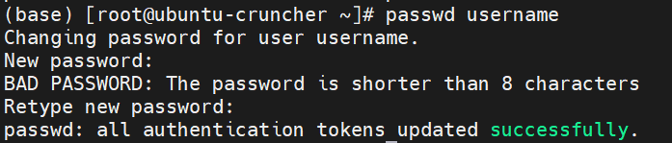passwd username

# Grant sudo privileges to the user name username:

## switch to root and check the sudoers file

su root

## add write permission to sudo file

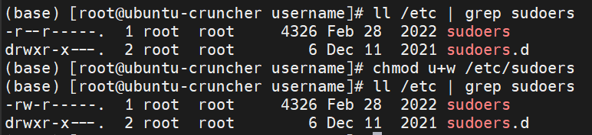chmod u+w /etc/sudoers

## open and edit /etc/sudoers

vim /etc/sudoers

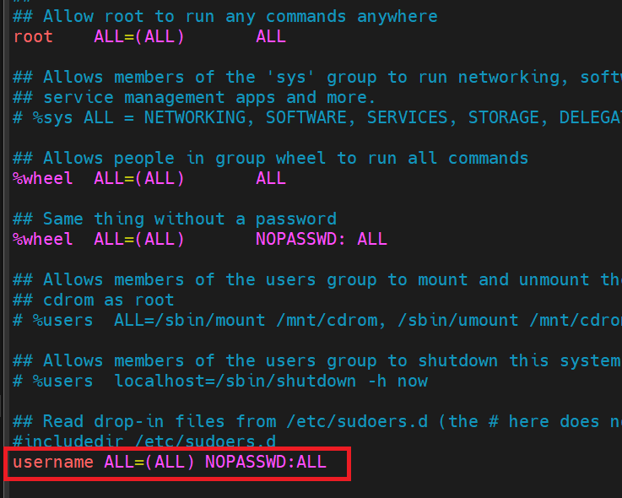add the code in the red box and save the change

## remove write permission of /etc/sudoers

chmod u-w /etc/sudoers

# Test